To create a profile –
- Use the link sent to you from the Pecatonica River Popcorn website giving you notice of your unique Seller ID.
- If you do not have that email, edit the link below to your unique Seller ID and email address:

http://pecatonicariverpopcorn.com/myprpopcorn/register.php?seller_id=6EEFMI&email=michele@greetingsofgold.com
The view of your profile while you are logged in will look like the image below:
- Note the URL shows your Seller ID – this is NOT the link you share with your customers.
- Click the ‘Email’ button in your profile. An email will pop up with the link in it that you will share with your customers.

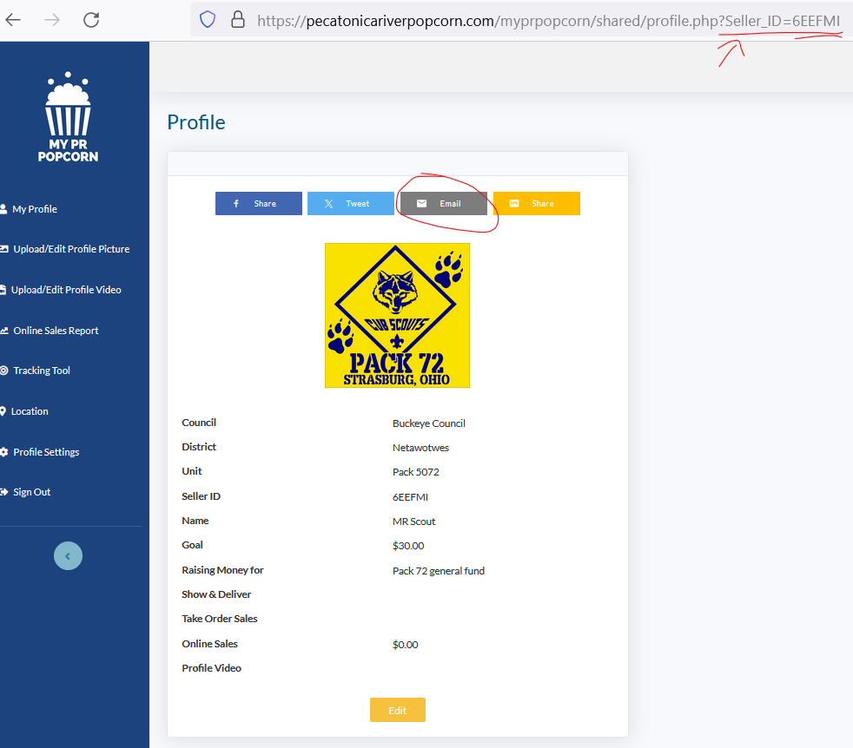

- Note that this sharable link shows a unique Scout ID created when you logged in to create a profile. This link will give the customer’s view of your profile, such as my generic pack profile below. This is NOT the unique Seller ID.
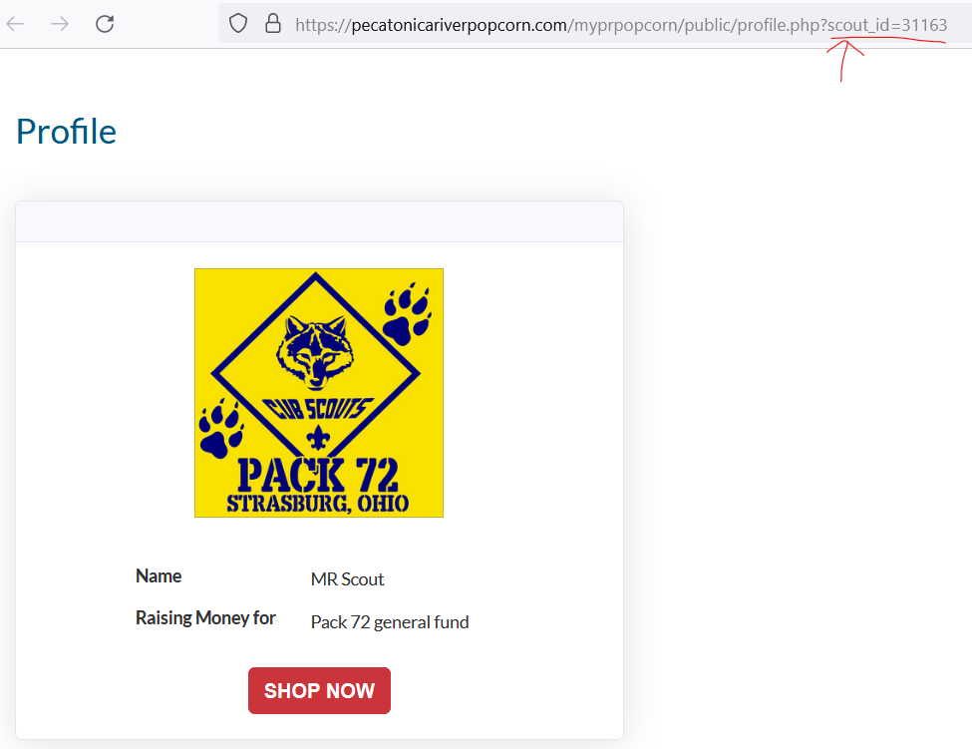

When the ‘SHOP NOW’ button is clicked, the customer will be sent to the online store.

Your unique Seller ID is found in the URL, and your name is noted at the top of the page.
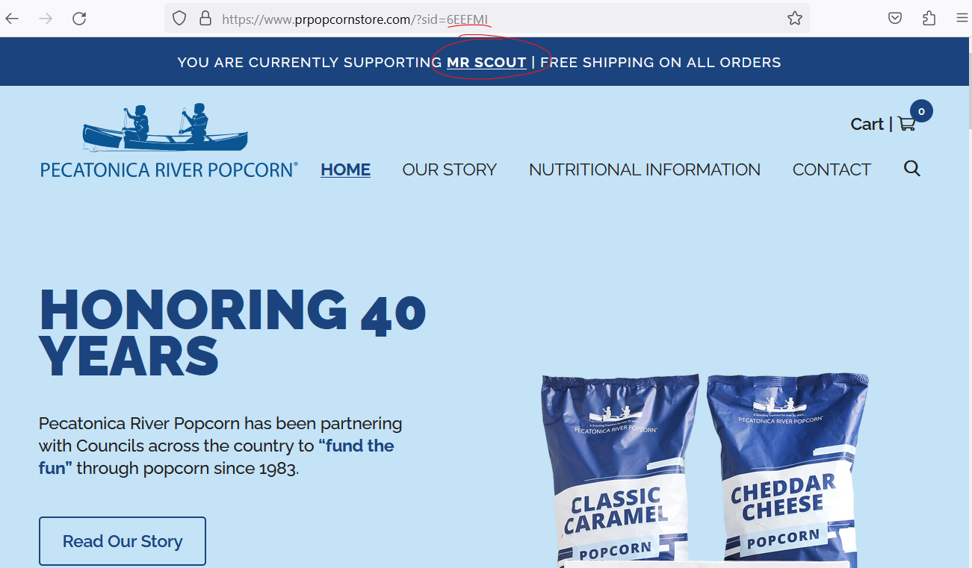

When the customer is done adding items to the shopping cart and clicks ‘Proceed to Checkout’, they will find the scout’s name and Seller ID listed there.
